**Case-1:**

Inserting a new movie in table.

**Inputs:**

Enter your choice: 1

Enter name: johnWick1

Enter code: JW1

Enter cost: 4000

Enter seat: 34

Enter day(dd): 24

Enter month(mm): 3

Enter year(yyyy): 2018

johnWick1 inserted successfully!!

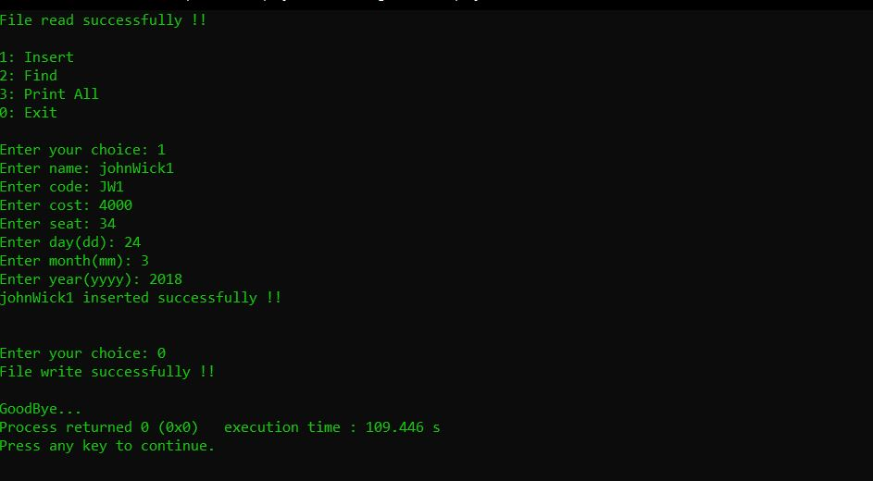

**Case-2:**

Searching a movie with date 20-4-2020

**Inputs:**

Enter your choice: 2

Enter day(dd): 10

Enter month(mm): 4

Enter year(yyyy): 2020

Searching result for 10:4:2020

Name: movie Date: 10:4:2020

Seat: 60 Cost: 600 Code: 118F

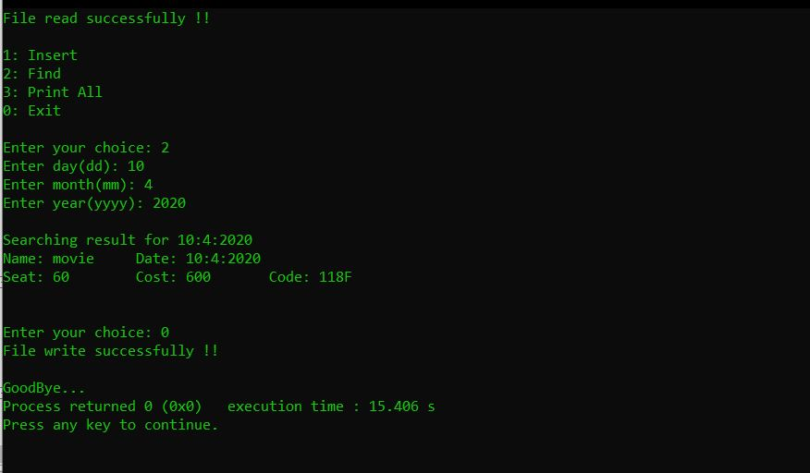

**Case-3:**

Printing complete table

**Inputs:**

Enter your choice: 3

